1. Bash Script to print the type of pattern given below.

1

1 2

1 2 3

1 2 3 4

1 2 3 4 5

Script and output:

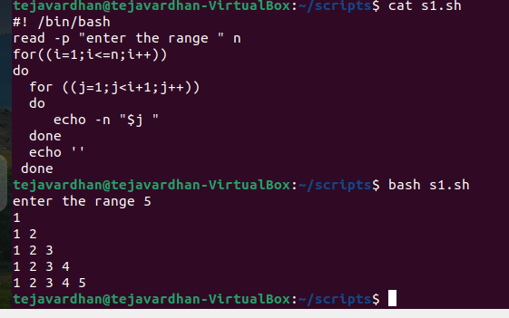

1. Bash Script for removing the repeated string.

Script :

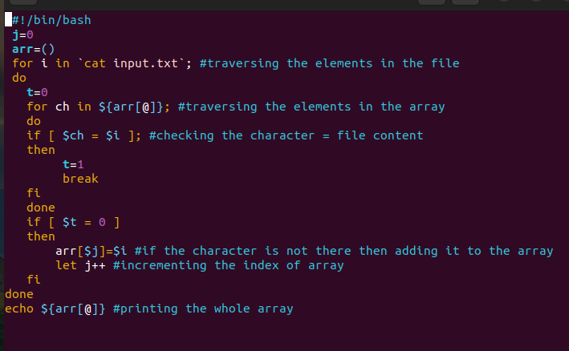

Before removing:

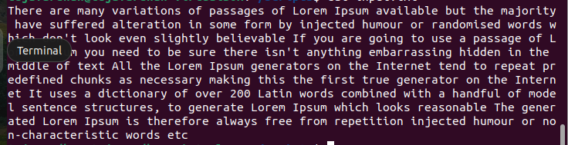

After removing:

